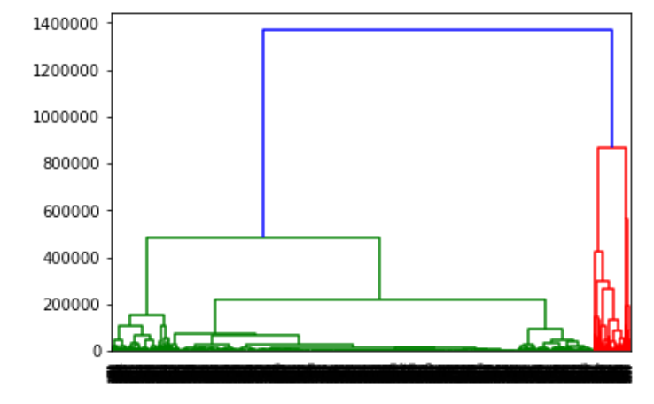
Dendogram clearly proving the presence of two clusters in unlabeled data.

Number of layers vs accuracy | model:( 8 neurons hidden layer ( all relu) , epochs:150)
Number of Layers | Accuracy %
0 | 93.80
2 | 95.32
4 | 91.64
6 | 95.60
8 | 93.16
10 | 93.88

Here we see that at 6 hidden layer it is giving optimal results.

Activation Function vs accuracy | model:(8 neuron -6 hidden layers(combination) )
Activation Function | Accuracy %
6 relu | 95.60
1 tanh 5 relu | 93.66
2 tanh 4 relu | 93.23
3 tanh 3 relu | 93.88
4 tanh 2 relu | 94.10
5 tanh 1 relu | 94.67
6 tanh | 94.96

From this it can be clearly observed that in this particular case when all 6 hidden layers have Relu function the Neural Network works best.

Number of Neurons vs accuracy | model:(6 hidden layers (all relu))
Number of Neurons | Accuracy %
2 | 50.39
4 | 89.34
6 | 91.21
8 | 92.51
10 | 95.03
12 | 95.01
14 | 94.81
16 | 93.08
18 | 95.60
20 | 89.99

Here at around 10 Neurons the highest accuracy is reached which is verified multiple times.

Hence the Neural Network Model that is experimentally giving best results is of following format:
Hidden layers: 6
Activation Functions: 6 Relu
Number of Neurons in each layer: 10
Ephocs: 150

KNN-Hyper tuning

Neighbors | Recall | Precision | Fmeasure | Accuracy
1 | 96.57 | 95.34 | 95.95 | 95.95
2 | 94.14 | 97.91 | 95.99 | 95.99
3 | 95.85 | 95.85 | 95.85 | 95.85
4 | 94.71 | 96.64 | 95.67 | 95.67
5 | 96.14 | 95.46 | 95.8 | 95.8
6 | 94.85 | 96.65 | 95.74 | 95.74
7 | 95.71 | 95.71 | 95.71 | 95.71
8 | 94.71 | 96.5 | 95.6 | 95.6
9 | 95.28 | 95.97 | 95.62 | 95.62
10 | 94.57 | 96.5 | 95.52 | 95.52

Here by experimental results we see the highest accuracy and Fmeasure can be acheaved when number of neighbors is 5

Evaluation Metrics of Classification algorithms:

1) Naive Bayes:

------ CLASSIFICATION PERFORMANCE OF THE NAIVE BAYES MODEL ------
Recall : 96.57142857142857 %
Precision : 73.23943661971832 %
Accuracy : 80.48956083513319 %
F-measure : 83.30252618607517 %

2)Rocchio:

------ CLASSIFICATION PERFORMANCE OF K-NEAREST-NEIGHBORS MODEL ------
Recall : 93.49282296650718 %
Precision : 61.21553884711779 %
Accuracy : 67.03454894433781 %
F-measure : 73.9871260886028 %

3)Support Vector Machine:

------ CLASSIFICATION PERFORMANCE OF THE SVM MODEL ------
Recall : 92.45647969052224 %
Precision : 94.84126984126983 %
Accuracy : 94.67649467649467 %
F-measure : 93.63369245837414 %

4)K Nearest Neighbors:

------ CLASSIFICATION PERFORMANCE OF K-NEAREST-NEIGHBORS MODEL ------
Recall : 96.14285714285714%
Precision : 95.4609929078014 %
Accuracy : 95.80071174377224 %
F-measure : 95.80071174377224 %

5)Artificial Neural Networks:

------ CLASSIFICATION PERFORMANCE OF THE NAIVE BAYES MODEL ------
Recall : 96.71428571428572 %
Precision : 98.40116279069767 %
Accuracy : 97.55219582433405 %
F-measure : 97.55043227665706 %

6)K-fold Decision Tree Model:

KFold(n_splits=5, random_state=None, shuffle=False)
TRAIN: [1389 1390 1391 ... 6942 6943 6944] TEST: [ 0 1 2 ... 1386 1387 1388]
------ CLASSIFICATION PERFORMANCE OF DECISION TREE MODEL ------
Recall : 97.26224783861672 %
Precision : 97.68451519536903 %
Accuracy : 97.4802015838733 %
F-measure : 97.47292418772562 %
TRAIN: [ 0 1 2 ... 6942 6943 6944] TEST: [1389 1390 1391 ... 2775 2776 2777]
------ CLASSIFICATION PERFORMANCE OF DECISION TREE MODEL ------
Recall : 98.42857142857143 %
Precision : 96.76966292134831 %
Accuracy : 97.55219582433405 %
F-measure : 97.59206798866855 %
TRAIN: [ 0 1 2 ... 6942 6943 6944] TEST: [2778 2779 2780 ... 4164 4165 4166]
------ CLASSIFICATION PERFORMANCE OF DECISION TREE MODEL ------
Recall : 97.39884393063583 %
Precision : 97.96511627906976 %
Accuracy : 97.69618430525558 %
F-measure : 97.68115942028986 %
TRAIN: [ 0 1 2 ... 6942 6943 6944] TEST: [4167 4168 4169 ... 5553 5554 5555]
------ CLASSIFICATION PERFORMANCE OF DECISION TREE MODEL ------
Recall : 97.9739507959479 %
Precision : 97.13055954088952 %
Accuracy : 97.55219582433405 %
F-measure : 97.55043227665705 %
TRAIN: [ 0 1 2 ... 5553 5554 5555] TEST: [5556 5557 5558 ... 6942 6943 6944]
------ CLASSIFICATION PERFORMANCE OF DECISION TREE MODEL ------
Recall : 97.55395683453237 %
Precision : 98.68995633187772 %
Accuracy : 98.12814974802015 %
F-measure : 98.11866859623734 %

------ AVERAGE CLASSIFICATION PERFORMANCE OF DECISION TREE MODEL ------
Recall : 97.55395683453237 %
Precision : 98.68995633187772 %
Accuracy : 98.12814974802015 %
F-measure : 98.11866859623734 %

